Tamaño de los diamantes

DBDC 2023!!

2016-08-25

Table of Contents

Existen 100 diamantes. La **suma** de *quilates* es:

$$∑quilate_{i}=90$$

Gráficamente:

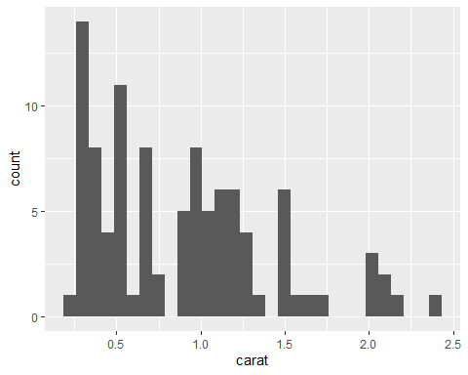

Acá algunos diamantes:

| carat | cut | color | clarity | depth | table | price | x | y | z |
| --- | --- | --- | --- | --- | --- | --- | --- | --- | --- |
| 0.91 | Ideal | I | VS1 | 62.1 | 57 | 3906 | 6.20 | 6.23 | 3.86 |
| 1.52 | Ideal | F | VS2 | 62.3 | 55 | 11405 | 7.37 | 7.33 | 4.58 |
| 1.29 | Ideal | H | VS1 | 61.2 | 57 | 8887 | 7.01 | 7.05 | 4.30 |
| 0.30 | Ideal | E | IF | 61.1 | 57 | 957 | 4.31 | 4.33 | 2.64 |
| 0.31 | Ideal | F | VS2 | 62.6 | 57 | 625 | 4.29 | 4.33 | 2.70 |

Los parámetros del modelo son:

# Seccion 1

| term | estimate | std.error | statistic | p.value |
| --- | --- | --- | --- | --- |
| (Intercept) | -951.3822 | 3196.733 | -0.2976108 | 0.7666501 |
| x | 3085.0237 | 3821.836 | 0.8072098 | 0.4215621 |
| y | 3958.5047 | 3694.128 | 1.0715667 | 0.2866294 |
| z | -11986.6292 | 2288.816 | -5.2370441 | 0.0000010 |
| carat | 8724.2649 | 1820.239 | 4.7929227 | 0.0000061 |

# Seccion 2

Otra seccion que muestra el gráfico.

